filter maps

collection

collection protocols

how to use the basics

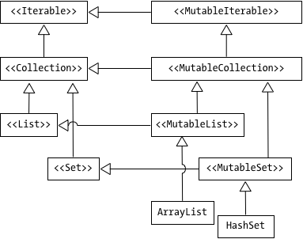



Why are we bothering

* Should I go through all the topics in collections
* What are the collections, by the way, should I describe them in detail
* Don't write raw loops (the filter and lambdas should actually be able to do the job), why should'nt I use raw loops, the syntax is there, why shouldn't I use it — because most of hte time, there's probably a better way of doing it
* Why do we call it a framework

What we'll cover;

* Arrays
* Collections, listOf, setOf, mapOf
* Sequences
* filter, map and flatmap

The questions I should be asking;

* What are collections
* Do I need them, we've already got arrays, wouldn't that suffice
* How many kinds are there
* Are there operations that are common to all Collections, or do I have the operation for each one of them
* What are the basic operations, how do I go through them
* Is the declarative (functional) way really better than if work with collections the imperative way? You know, like how we did it in Java. Are there downsides (decompiler), and this is where sequences comes in